<https://kvhra.shrm.org/> SHRM Chapter #: 694 P.O. Box 1445, Waterville, ME 04903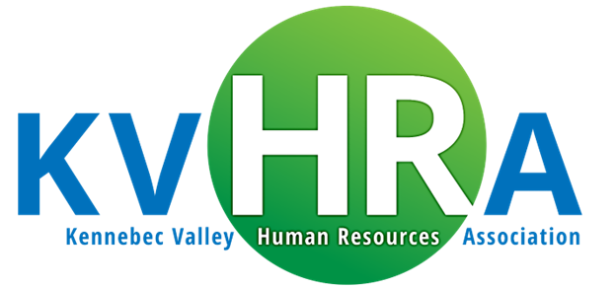

***2024 Programs/Meeting Information***

*(Topics & speakers are subject to change. Please review the registration communications carefully in the event there are meeting changes)*

|  |  |  |  |  |  |
| --- | --- | --- | --- | --- | --- |
| Morning Agenda  7:30 a.m. – 7:50 a.m. – Registration & Networking (Breakfast if in-person meeting)  7:50 a.m. – 8:00 a.m. - Sponsor Presentation  8:00 a.m. – 9:15 a.m. – Speaker Presentation and Q&A  9:15 a.m. – 9:30 a.m. - Chapter business meeting | **Date** | **Location** | **Topic** | **Speaker(s)** | **Sponsor** |
| 02/14/2024 | Best Western  Waterville | **Keeping Current on Compliance: Tips from a Law Librarian** | **Jessica Lundgren** Maine State Law & Legislative Reference Library | **Strategic HR US**  (Conf Pass Draw 1/12/24) |
| 03/13/2024 | Calumet Club  Augusta | **Introduction to DEI and Maine Demographics** | **Shiva Darbandi**  State of Maine, Bureau of Human Resources | **CGI Benefits Group**  Jennifer McCurry |
| 4/10/2024 | Best Western  Waterville | **Employment Law News** | **Anne-Marie Storey, Esquire**  Partner, Rudman Winchell | **Healy & Associates** Matt Arbo |
| 5/15/2024  Jan makeup | VIRTUAL ONLY  Exception HR Conf | **Surveying the Compensation & Benefits Landscape 2024** | **Kim Rummler** KMA HR Consulting | **KMA HR Consulting** Jason Breard / Sarah Cummings |
| 6/12/2024 | Calumet Club  Augusta | **Importance of Effective Communication in Human Resource Development** | **Cari Gochenouer**  State of Maine, Bureau of Human Resources | **HealthEquity**  Stacie Jackson |
| 09/11/2024 | Calumet Club  Augusta | **2030 Workforce – What should HR be doing today to get ready** | David Pease  Bangor Savings Bank  Senior VP/Director Talent, Diversity & Inclusion | **Puzzle**  Ricky Graf |
| 10/9/2024 | Best Western  Waterville | **Domestic Violence: Foundations and Effects in the Workplace** | **Jon Heath**  Education Director – Family Violence Project | **Paylocity**  Lubo Stoyanov  Ryan Legere |
| 11/13/2024 | Calumet Club  Augusta | **Building an Effective Safety & Health Program** | **Michelle Martin, Sr. Loss Control Consultant**  **Jeff Lewis, VP of AMD & Loss Control**  Maine State Trust Group | **Maine State Group Trust c/o Cross Insurance TPA**  Jeff Lewis / Michelle Woodard |
| 12/11/2024 | Best Western  Waterville | **Ethical Boundaries and Leadership** | **Karen Shorey, President**  Impact Leadership Group | **Varney Benefits**  Scott Smith |

Rev. 11/11/24 *Meetings generally held the 2nd Wednesday of the month, no meetings in July & August.*