<https://kvhra.shrm.org/> SHRM Chapter #: 694 P.O. Box 1445, Waterville, ME 04903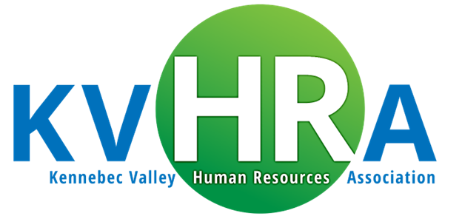

***2025 Programs/Meeting Information***

*(Topics & speakers are subject to change. Please review the registration communications carefully in the event there are meeting changes)*

***AGENDA***

*7:30 – 7:50 am Registration & Networking (light refreshments provided)*

*7:50 – 8:00 am Sponsor Presentation*

*8:00 – 9:15 am Speaker Presentation and Q&A*

|  |  |  |  |  |
| --- | --- | --- | --- | --- |
| **Date** | **Location** | **Topic** | **Speaker(s)** | **Sponsor** |
| 01/08/2025 | Best Western  Waterville | **Employment Law News** | **Peter Lowe, Partner**  Brann & Isaacson | **Nimble Group**  (Conference Pass Drawing) |
| 02/12/2025 | Calumet Club  Augusta | **Ladder of Inference** | **Danielle Fox**  Director – ME Legislature, Policy & Legal Analysis | TBD |
| 03/12/2025 | Best Western  Waterville | **NEW Maine Paid Family Medical Leave**  **Long Term Care Update** | **Bucky Gahagan**  Vice President, Cross Insurance  **Terence Ryan**, Director Market Development  **Jason Ouellette**  Senior Account Executive | **Cross Insurance** |
| 04/09/2025 | Best Western  Waterville | **State Economist Update – Trends in Maine’s Demographics/Labor Market** | **Amanda Rector**  Maine State Economist | TBD |
| MAY 5-8 2025 | Samoset | **30th Annual Maine HR Convention** |  | **Nimble Group** |
| 6/11/2025 | Calumet Club  Augusta |  |  |  |
| 09/10/2025 | Calumet Club  Augusta |  |  |  |
| 10/8/2025 | Best Western  Waterville |  |  |  |
| 11/12/2025 | Calumet Club  Augusta |  |  |  |
| 12/10/2025 | Best Western  Waterville |  |  |  |